Provisioning Azure Stream Analytics job & streaming units

Lab5: Create ASA job & configure streaming units

Overview

In this lab, you will provision an HDInsight cluster. You will then run a sample MapReduce job on the cluster and view the results.

What You’ll Need

To complete the labs, you will need the following:

* A web browser
* A Microsoft account
* A Microsoft Azure subscription
* A Microsoft Windows, Linux, or Apple Mac OS X computer on which the Azure CLI has been installed.
* The lab document.

Provisioning and Configuring an Azure Stream Analytics job

The first task you must perform is to provision Stream Analytics jo

**Note**: The Microsoft Azure portal is continually improved in response to customer feedback. The steps inthis exercise reflect the user interface of the Microsoft Azure portal at the time of writing, but may not match the latest design of the portal exactly.

Provision an HDInsight Cluster

1. In a web browser, navigate to [http://portal.azure.com.](http://portal.azure.com/) If prompted, sign in using the Microsoft account that is associated with your Azure subscription.
2. In the Microsoft Azure portal, click **All resources**, and verify that there are no existing Stream Analytics job in your subscription.
3. In the menu (on the left edge), click **Create a resource**(indicated by a **+**), and in the **Data + Analytics** category, click **Stream Analytics job**. Then provide the following details
   * **Job Name**:*Enter a unique name (and make a note of it!)*
   * **Subscription**:*Select your Azure subscription*
   * **Resource group:** *Select the appropriate existing Azure resource group***.** *Or can create a new one.*
   * **Location:** *Enter a data-center location for provisioning Stream Analytics job.*
   * **Hosting environment:** *Enter the job hosting environment- default (Cloud) or else*

*On-premise IoT Edge device hosting option is* ***Edge***

* + **Streaming units:** *Choose the number of Streaming Units as pool of resources for computations of your ASA job.*

1. After you have clicked **Create**, wait for the status of the job changed as **Created.**

View ASA job Configuration in the Azure Portal

1. In the Microsoft Azure portal, browse your resources and select your ASA job just provisioned.
2. Under Configure section of the respective ASA job, select Scale. You should be able to configure Streaming units (1 to 120) compute resources for scaling out for your job.

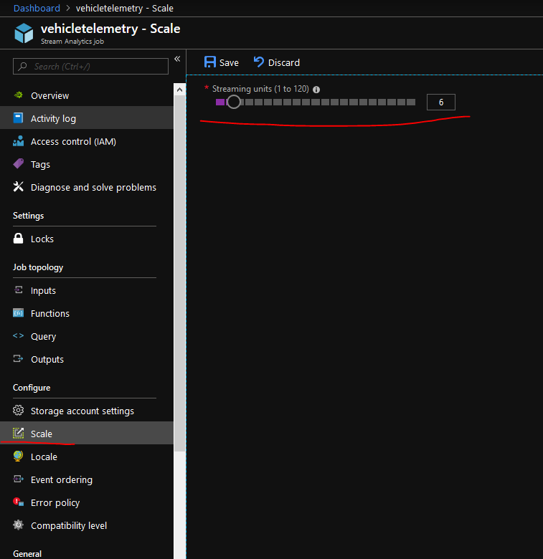

Monitor ASA job performance

Using the Azure portal, you can track the throughput of a job.

